//Om Shree Gurubhyo Namaha//

**ACCIDENT & SURVIVAL**

***- R. Subha Lekha***

*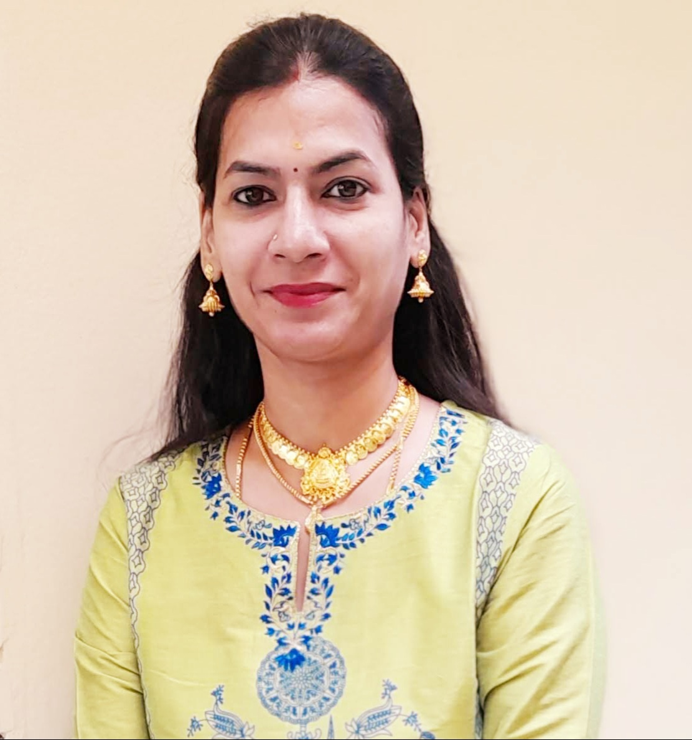R.Subha Lekha is a student of JKR Astro Research Foundation. She pursued her Masters in Vedanga Jyotisha holding First Rank from Yoga Samskrutham University, Florida USA. Presently she is pursuing her PhD in Medical Astrology under the guidance of Dr. N.V.R.A. Raja sir and also M.SC Psychology from Dr. B.R. Ambedkar University. She is by profession High School teacher.*

*Author’s Note :*

*I am glad that I have got an opportunity to write an article about Accident & Survival predictions through Jeeva & Sareera analysis.* *An accident or mishap is an unforeseen, unplanned, unexpected and undesirable event, especially one resulting in damage or harm. When a person meets with an accident and afterwards goes through the mental trauma, the 1st thing that comes to his/her mind on recovering is that he/she is having a bad time and/or the planetary positions are not favourable to him/her. Everything that happens in the life of an individual is influenced by Planets. In my opinion most of these accidents can be avoided and a good astrologer can advices better how to avoid these high risks moments of life.*

Every sign has its own quality. Hence every person born in a sign will have certain common and important traits. The Ascendant in Aries is the most prone for accidents whereas Virgo is least prone for accidents. This is because of the excess nervous energy the Aries lagna native and his inability to control it properly. Similarly Pisces lagna native is also prone to accidents. The two faced fish that Pisces represents cannot take decisions quickly due to their weak reflex action. The Virgo lagna native is more cautious and will always think twice before initiating action. Libra natives are well balanced and hence they are not generally prone to accidents. In a general manner the natives with Ascendants in the Fixed signs (Taurus, Leo, Aquarius) are less prone to accidents. They do not like changes, experimentation and hence they follow a fixed routine which probably is the reason.

The sign occupied by the Sun plays an important part in determining the vitality of the native. The more the vitality the better the strength to recuperate and less the damage incurred. Sun is very hot and a fiery planet. It is comfortable when it occupies similar signs. But when it occupies Watery signs like Pisces, Cancer and Scorpio it will not be comfortable and hence cause accidents. Similarly when Sun occupies Sagittarius, Capricorn the fiery nature gets centred and concentrated to a particular location and this protects the individual. Similarly when the Sun occupies the fixed signs Taurus, Leo and Aquarius the fiery nature seems to be controlled by the individual and hence there is less chance of harm and accidents.Planets Mars and Saturn Rahu ketu are associated with Accidents. Mars is the symbol of getting hurt. Mars is the lord of blood and violence, firearms, weapons. Rahu gives sudden events in life. So It represent suddenness/sudden accidents in life. Venus role is also important when it comes to accidents by vehicle. Venus is the karaka of vehicles. Saturn is responsible for the accidents occurred by iron or machines. Mars is responsible for the accidents occurred due to fire or explosion/explosive material. Saturn also responsible for the accidents occurred due to animals. Moon is responsible for the accidents happened by water. Ketu in the 8thth house causes accidents. The planet Mercury rules transport in our immediate environment including bikes, scooters, cars, etc. For any immediate transport accident we look to Mercury, Gemini, or the 3rd house. For long distance travel we look to Sagittarius, Jupiter or the 9th house*.*

Moon plays an important role in accidents of childhood as Moon refers to childhood. Natives who are prone to accidents can have some specific placement of planets or planetary combinations in their birth chart. Position of Rahu and Mars in ascendant or in 2nd house, Mars or Saturn in ascendant, mars or Saturn in 3rd house, mars or Saturn in 5th house, Mars and Saturn in 2/12, 6/8 combinations, Saturn, Moon, Mars in 2nd, 4th , 10th , 12th Houses, afflicted 4th house and 10th house.

Accidents may also occur during the Dasha and bhukti of maraka and badhaka lords or planets placed therein. For the timings of accident dasha period needs to be checked up to sookshma level. When these combinations are connected with the accident prone houses (4,8,12) give accidents or hospitalization during its period. Connection with 6th house can also give accidents.

**MEGASTAR CHIRANJEEVI**

Chiranjeevi (Konidela Sivashankara Vara Prasad) was born on 22 Aug 1955, 10:20hrs, at Mogalthur, Narsapur, West Godavari Dist., A P. Chiranjeevi is a South Indian mega film star and a political leader from Andhra Pradesh.

He met with a major accident while he was travelling from Hyderabad to Chennai by air. It was around 7.59am on November 15, 1993, that due to technical problem, the flight had to be crash-landed in agricultural fields in Chittoor district of Andhra Pradesh. The pilot of the flight managed to crash-land the flight without any injuries or any casualties to the passengers.

We will study this megastar’s chart, applying Jeeva/sareera principles to arrive at timing of accident and observe effects of accident.

|  |  |  |  |
| --- | --- | --- | --- |
|  |  | **KE** |  |
|  | **NATAL CHART** | | **JU** |
|  | **MA, ME,**  **SU, VE** |
|  | **RA** | **ASC, SA** | **MO** |

|  |  |  |
| --- | --- | --- |
| **PLANET** | **STAR** | **PADA** |
| ASC | Chitha | 4 |
| SUN | Makha | 2 |
| MOON | Chitha | 2 |
| MARS | Makha | 2 |
| MERCURY | Pubba | 3 |
| JUPITER | Aslesha | 2 |
| VENUS | Makha | 1 |
| SATURN | Visakha | 1 |
| RAHU | Jyeshta | 4 |
| KETU | Mrigasira | 2 |

**OBJECTIVES : To validate**

“Whenever DBA gets connection with 4,6,8,12th houses and maraka Mars then events like accidents may happen”.

“If same DBA gets connection with 5th, 11th houses and strong yogakaraka then cure/ survival is assured”.

“The yog of accident could be numerous but if jJpiter aspect is on lagna or 5th lord in the natal chart then native will be saved during DBA and transit.”

**OBSERVATIONS**

* Yogakaraka Planet is Mercury
* Digbala Planets are Mercury, Jupiter and Rahu
* Bhinnapada Planets are Ketu, Moon and Saturn
* Maraka Planet is Mars
* Badaka Planet is Sun.
* Mars and Kethu in Sookshma Nakshatra Parivarthana.

|  |  |  |  |
| --- | --- | --- | --- |
|  |  | **KE** |  |
|  | **NATAL CHART** | | **JU** |
|  | **MA, ME,**  **SU, VE** |
|  | **RA** | **ASC, SA** | **MO** |

In Natal chart we observe that native is born in Tula lagna. For Tula lagna, Mercury is the Yogakaraka, Mars is the maraka and Sun will be the badaka. 4th and 5th lord Saturn is posited in lagna which is his exaltation house and in airy sign.

As per Meena2 principle, **“Planets in the house will not deliver the result, but its star lord will deliver the results favorable or unfavorable”.**

* Saturn , located in lagna kendra, is in the star of Jupiter who happens to be the 3rd and 6th lord posited in 10th house. Jupiter is in exaltation. So, Saturn will deliver the results of 1,3,4,5,6,10 houses . Also Saturn aspects its star lord the 6th lord Jupiter through 10th aspect.
* 1st and 8th lord Venus is in 11H of Labhasthana also a badaka house.Venus is in the star of Ketu who is posited in 8H. Saturn aspects venus also.
* 9th & 12th lord Mercury who is yogakaraka for the native is posited in 11H . Mercury starlord Venus who happens to be the 8th lord together is in conjunction with 11th lord Sun, badaka planet.
* Due to above reasons, accident had to happen during Saturn dasa, Saturn bukti and Mercury antara.
* Karaka for accident Mars who is the 2nd & 7th lord which is maraka houses for the native is posited in 11th H with conjunction badaka planet Sun, 8th lord Venus and 12th lord Mercury.
* Dasa and Bhukti lord Saturn through Bhinnapada gets connection with 2H of Maraka aspecting karaka Mars posited in 11H through 10th aspect. Mars also aspects dashadipathi saturn. Saturn aspects 8H posited Kethu. 8th H indicates for sudden events.
* Antara lord Mercury is a yogakarakadipathi and 12th lord.

So, here we could observe that DBA has got strong connections with 6,8,12 houses and karaka Mars, events like accidents indicated.

**Transit Chart Analysis**

The native was running **Saturn Dasa – Saturn Bhukti – Mercury Antara.**

Saturn dasa started from **14-05-1993 to 13-05-2012**.

|  |  |  |  |
| --- | --- | --- | --- |
|  |  | **Ke (Su)** |  |
| **Sa (Ma)** | **TRANSIT CHART** | |  |
|  |  |
|  | **Ma (Sa)**  **Mo (Sa)**  **Ra (Sa)** | **Me (Ra)**  **Su (Ju)**  **Ju (Ra)**  **Ve (Ra)** |  |

This event occurrence is validated in transit chart as described here below.

In transit, Dasha and Bhukti lord Saturn is in his own house of Kumbha an airy sign is aspecting natal posited badakadipathi Sun, karaka Mars, 8th lord Venus and 12th lord Mercury. Sun in 11H is strong in Leo along with Yogakaraka Mercury in transit came above the natal dasha and bhukti lord saturn helped the native to survive the accident with no injuries or casualties.

Sudden events like accident happened because of karaka mars in transit is in 2H from natal lagna which is his own house Scorpio. Posited above the natal bhinnapada saturn. Here to be noted that Mars and Saturn are in ‘**SOOKSHMA NAKSHATRA PARIVARTHANA’.**

**“Whenever DBA has got 5th, 11th  houses with Yogakaraka connections to DBA then Survival or recovery is assured”.**

**Jeeva and Sareera Planets of 1,6,8,12th bhavas and Mars are shown below.**

|  |  |  |  |
| --- | --- | --- | --- |
| **Bhavas** | **Bhava Lord** | **Jeeva** | **Sareera** |
| 1H | Venus | Ketu | Sun |
| 6H | Jupiter | Sun | Ketu |
| 8H | Venus | Ketu | Sun |
| 12H | Mercury | Sun | Ketu |
| Mars | Mars | Ketu | Sun |

|  |  |  |  |
| --- | --- | --- | --- |
| **Bhavas** | **Bhava Lord** | **Jeeva** | **Sareera** |
| 5H | Saturn | Jupiter | Sun |
| 11H | Sun | Ketu | Sun |

**For Cure**

**JEEVA SAREERA ANALYSIS**

**“Whenever jeeva and sareera planets of 4,6,8,12th houses and karaka mars gets connection with DBA then accident like events happen”.**

* 1st & 8th Lord Venus is in the star of Ketu, so Ketu becomes Jeeva planet. Jeeva planet Ketu is in the star of Mars. Mars is conjoined with sun and Sun is strong in leo snatches the power from Mars and becomes Sareera planet.
* 6th Lord Jupiter is in the star of Mercury and Mercury is in Leo sign conjoined with bhavalord Sun. Sun snatches power from Mercury and becomes Jeeva planet. Jeeva planet sun is in the star of Kethu, so kethu becomes Sareera planet.
* 9th & 12th lord Mercury is in the star of Ketu and Ketu becomes Jeeva Planet. Jeeva planet ketu is in the star of Mars, and sun owns the house becomes Sareera planet.

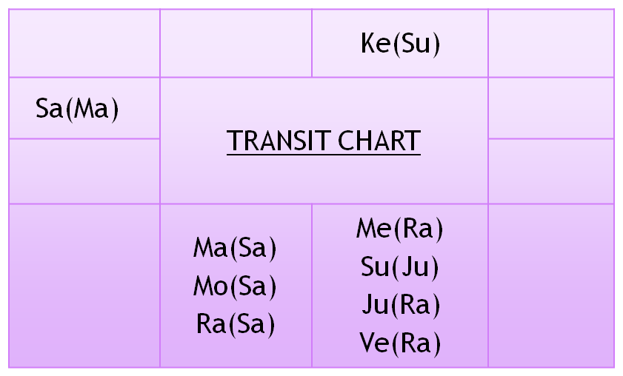 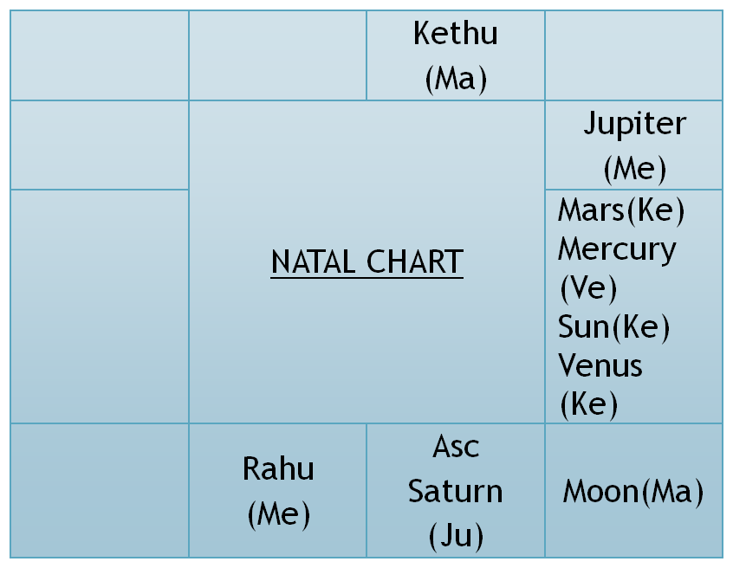

* Karaka Mars is in the star of Ketu . Ketu becomes Jeeva planet. Jeeva planet ketu is in the star of Mars and is with sun. So sun becomes Sareera planet.

In transit , Sun the jeeva planet of 6th & 12th house and sareera planet of 1st, 8th and karaka Mars is above natal dashadipathi and bhukti lord Saturn.

Jeeva planet of 1st,8th and karaka mars and sareera planet of 6th & 12th house ketu is in the star of Sun who is the 11th lord the labhadipathi. Ketu is aspected by natal saturn through bhinnapada.

**Note :** Ketu in natal and transit chart is in Taurus sign which indicates agricultural land. The native’s flight was crash landed in agricultural field.

**Conclusion :**

“Whenever the Jeeva and Sareera planets along with DBA gets connected to 5th & 11th houses or Yogakarakadipathi then recovery or survival is assured”.